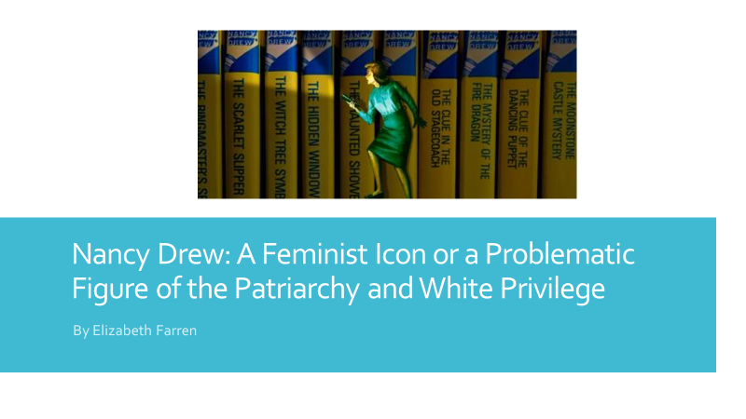

Hello everyone, my name is Elizabeth Farren, and I am a first year student here at BGSU. I would just like to welcome you to my presentation on “Nancy Drew: A Feminist Icon or a Problematic Figure of the Patriarchy and White Privilege.” I hope this presentation is informative and helps you understand the importance of diversity, gender, and inclusion in academia, media, and beyond.

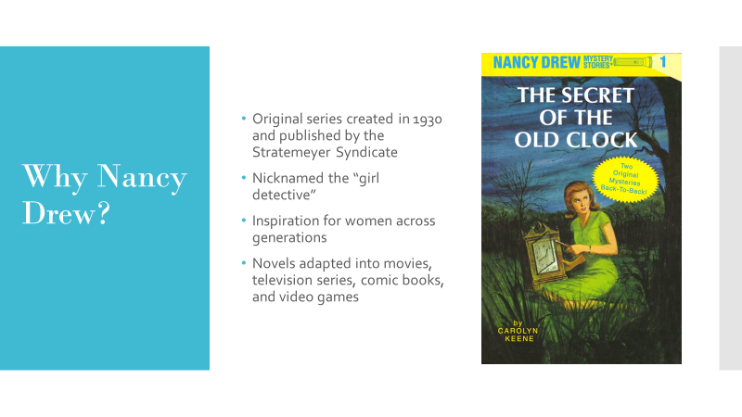

As I mentioned I am a first year student hear at BG, and in my first semester I took Writing 1120. The course theme was Introduction to Detective Fiction, and for my final research paper and as a women’s studies minor, I wanted to write about a prominent female character in detective fiction and her feminist values and decided to focus on Nancy Drew. The Nancy Drew Mystery Series was originally created in 1930s by a collective group of authors from the Stratemeyer Syndicate. The series became extremely popular, and due to the presence of a prominent female character, Nancy Drew was quintessentially nicknamed the “girl detective.” The has remained popular across generations, and has been continually adapted into movies, television shows, comic books, and video games.

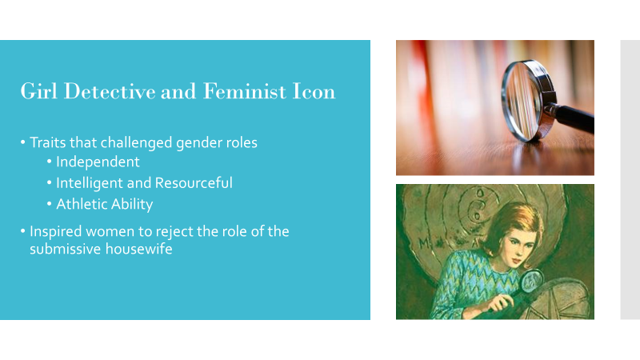
Nancy Drew embodied many traits that challenge traditional gender roles and counteract women’s perceived essence of femininity and passivity.
One of these traits is her independence, a quality which is symbolized by her iconic blue roadster. Nancy’s freedom is essential to her ability to solve mysteries and escape from the confining clutches of the patriarchy, as she is uninhibited by the dauntless tasks of household chores, marriage, or child rearing. Likewise, she rarely depends on men, as her boyfriend takes on the sidekick role, and her supportive father does not interfere with her cases. Nancy disregards the concept that women should be occupying a subservient place beneath her male counterparts.
Nancy’s intellect and logical reasoning help her solve mysteries and also reject the stereotype that women are intellectually inferior to men. Using logical reasoning, she is able to outsmart and solve mysteries which even male authority figures, like the police and her lawyer father, find perplexing. Therefore, Nancy does not fit the stereotype of the helpless and dependent women.
Lastly, Nancy is very athletic, as she expertly swims and dives, navigates planes and boats, runs after suspects, and escapes from traps and tight compartments. She ignores the assumption that women are weak and exist only as attractive objects to men, using her body as a tool to solve her mysteries. Her strength threatens the culture of male domination that the patriarchy uses to suppress women physically, emotionally, and mentally.
All of these characteristic have a traditional masculine connotation, and by reading about a women who was so intelligent and independent, many women aspired to be her and reject the role of submissive housewife.

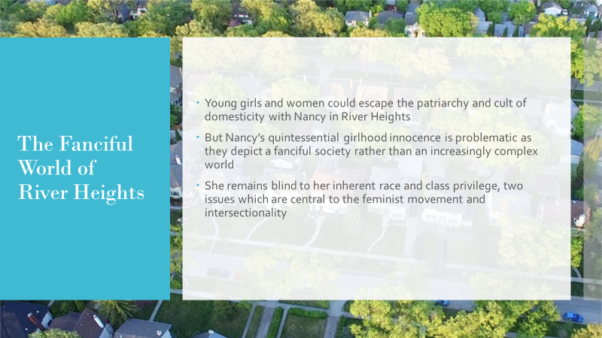
In fictional River Heights, Nancy remains unrestrained by the cult of domesticity and conformity, a world which young girls could use to escape from the patriarchy yet still retain their femininity. Nancy’s quintessential girlhood innocence, however, is problematic as they depict a fanciful society rather than an increasingly complex world.
Even though the act of solving mysteries counters traditional gender roles, yet her naivety and characteristic innocence make her problematic, as she is blind to her inherent race and class privilege, two issues which are central to the feminist movement and intersectionality.

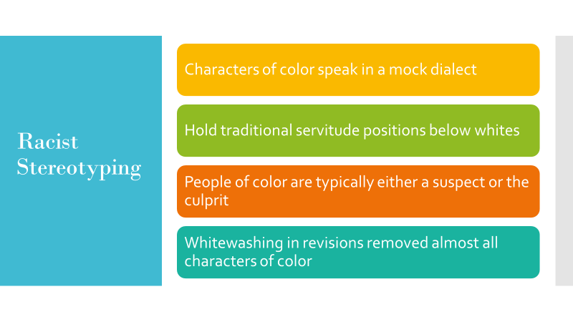
Although the Nancy Drew series continued to remain popular throughout the 1960s, it received criticism for the use of racist stereotypes, and as a result was rewritten to exclude the offensive characterizations. Many characters of color speak in mock dialect and hold traditional servitude positions to whites, alluding to a lack of intelligence and inferiority. The assumption that blacks are inherently liars, untrustworthy, and criminals is also evident in Nancy’s adventures, as people of color are typically either a suspect or the culprit. The blatant use of racist stereotypes allows the audience to perceive these characterizations as realistic and acceptable. In the 1960s, the novels were revised, eliminating all characters of color, favoring whitewashing. The idea that characters of color either need to be portrayed in a racist light, or not at all, contradicts Nancy’s feminist traits, as Nancy is written in a way where she never questions her white privilege.

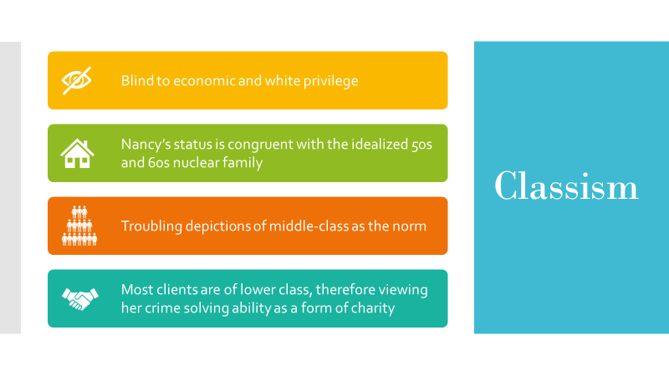
Nancy’s view of race is not the only issue, as she also is naïve to the fact that she holds white and economic privilege as a member of the upper-middle class, a part of her identity which the authors continually emphasize. Even in the original 1930s novels, Nancy and her family remain untouched by the Great Depression and her financial status is never jeopardized. Nancy’s status is congruent with the idealized 50s and 60s American Dream of the white, suburban family and a white picket-fenced house. This is troubling as the authors and Nancy depict the upper-middle class as the norm. Lastly, most of her cases involve the theft or absence of a priced document or heirloom, stolen from a lower-class individual who desperately needs the money. By finding the prized object she not only solves the mystery, but she elevates these people to her middle-class standards, restoring them to “their accustomed places in society.” Nancy does not recognize that by depicting her socioeconomic status as the norm, she is projecting an idealized version of American society, subtly equating all those below her as lesser in their value to society.

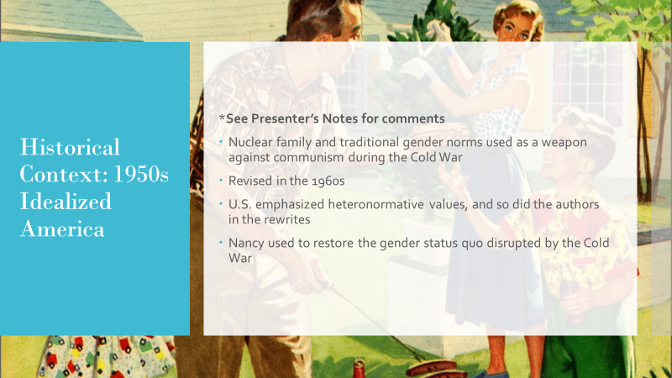
Recognizing that the racist stereotypes were problematic, the originals novels were revised in 1960s. At the time, the United States was at the height of the Cold War and emphasized traditional family and gender values to create feelings of security and solidarity among Americans. The nuclear family was then used as a weapon against communism during the height of the Cold War. In addition, these values were used to contrast the disruption of gender roles created by the second-wave feminists. As the U.S. emphasized heteronormative values, and so did the authors in the rewrites. As a result, the authors continually emphasize her appearance and make her more dependent on men than in the original novels.

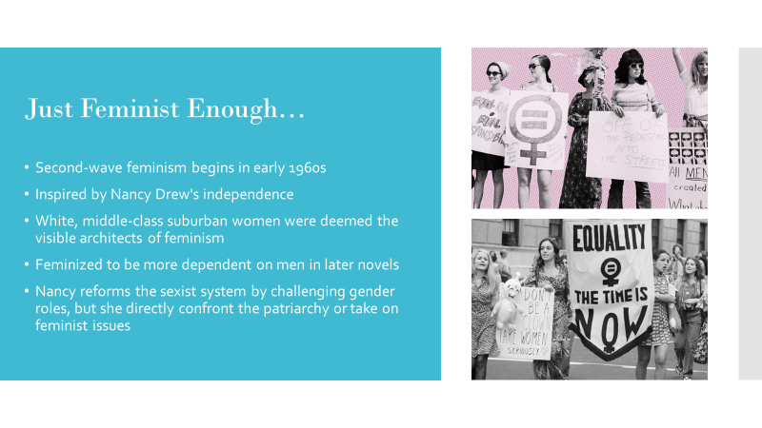
The second-wave feminist movement began in 1960s, as women inspired by Nancy Drew to break the glass ceiling of the patriarchy. Although second wave feminists had good intentions for uniting women and feminists under a single message of sisterhood, their failed acknowledgement of intersecting identities made them inherently controversial.
They saw women’s experience with sexism through the lens of the white, upper-middle class, dissatisfied housewife, and so their privilege made them the visible architects of feminism. As a result, women of color and poor women’s experiences were invalidated, as white liberal feminists worked within the patriarchy to obtain the status of white men. Some might argue that even though “Nancy does not take on women’s issues per se, solving a mystery is an act of power. Nancy, however, never questions her white or economic privilege, and remains content in her current niche in society. She is comparable to a white, liberal rather than a progressive feminist figure as she works within the patriarchy to attain the status of white men.

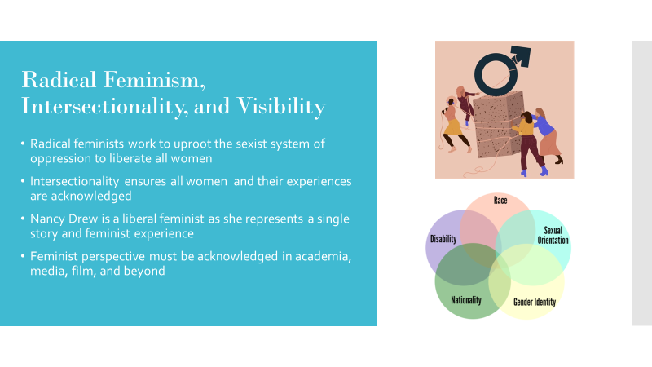
While many women consider Nancy Drew a feminist, her status as a feminist icon is controversial, as she does not directly confront the patriarchy, her privilege, or other feminist issues. Radical feminism is all-inclusive, regardless of race, class, gender, or sexual orientation, a movement which seeks to raise society’s conscience to differing sexist experiences and liberate all women. Although Nancy Drew was a feminist figure of the 1960s, her identity does not align with the intersectional feminists of today, as she only represents a single feminist story. While female characters are important, not every prominent female figure is a feminist. Inclusion and gender are very important topics when it comes to literature, film, and television, and I hope this presentation and paper help encourage these discussions on campus, in academia, and abroad.

Thank you all for viewing my presentation! I hope it was educational and demonstrated the importance of diversity in academia and beyond, and how we cannot claim one perspective as universal. Lastly, I want to acknowledge all feminists, and I hope that you will all have the space, visibility, and opportunity to have their voices heard and stories told. Thank you!

