62
Hockey is a sport whose only constant is chaos. It is a spectacle; A nonstop barrage of insanity that assaults all normality. The prime example of this is the Stanley Cup Playoffs, an annual bloodbath that reminds us of the instability of our world. The antithesis of this would be the regular season, where everything can feel predictable. Of course, there are interesting things that happen throughout the season, but rarely are there remarkable results. There are two exceptions to this.
Detroit Red Wings, 1995-1996
62 – 13 – 7 , 131 Points
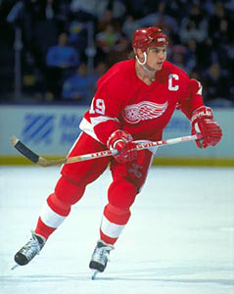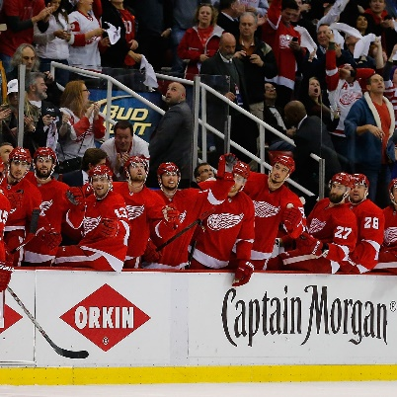
Tampa Bay Lightning, 2018-2019
62 – 16 – 4 , 128 Points
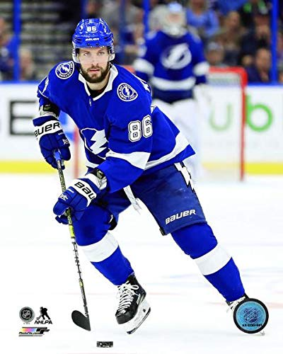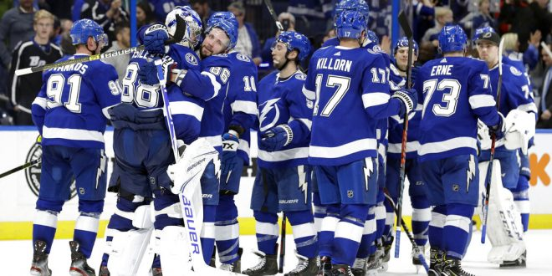
In 1996 the Detroit Red Wings posted 62 wins in a regular season. It was remarkable, but nobody would truly know how outstanding it was for some time. 23 years later, the Tampa Bay Lightning matched the 62 win total. It was just as unlikely as the first time it had happened, and like everything else in hockey, it showed us how chaos manifests in our reality.
These two teams were forces of nature. They were near unbeatable, and posted historic numbers. But, I realize that some of you reading this might not be hockey fans. Heck, the NBA has had a team crack the 60 win mark every year since 1960. So let me illustrate for you; This does not happen in hockey. 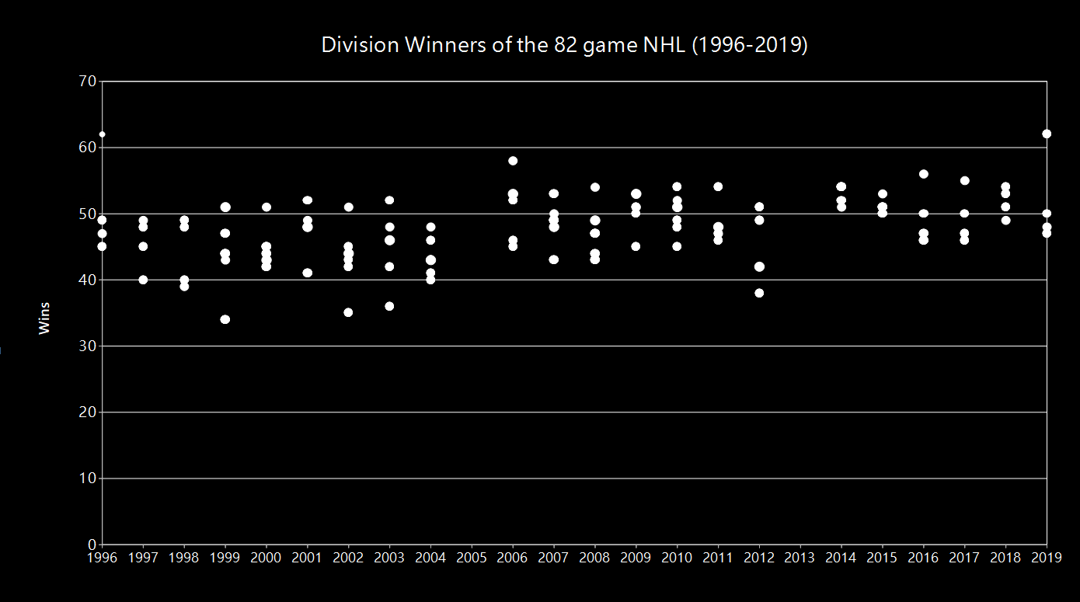 The NHL has been playing an 82-game regular season since 1996. This was a few years after four new teams had joined the league (Lightning, Senators, Panthers, Ducks), and just before four more would join between 1998 and 2000 (Thrashers, Wild, Blue Jackets, Predators). Within this decade, the NHL set its concrete of 30 teams playing 82 games each for the regular season. Above, you can see every division winner since the start of this era. Winning a division is tough, but it doesn’t necessarily mean they were a good team. Ten of these teams had a win record below .500. On average, though, if you won your division you probably won about 48 games.
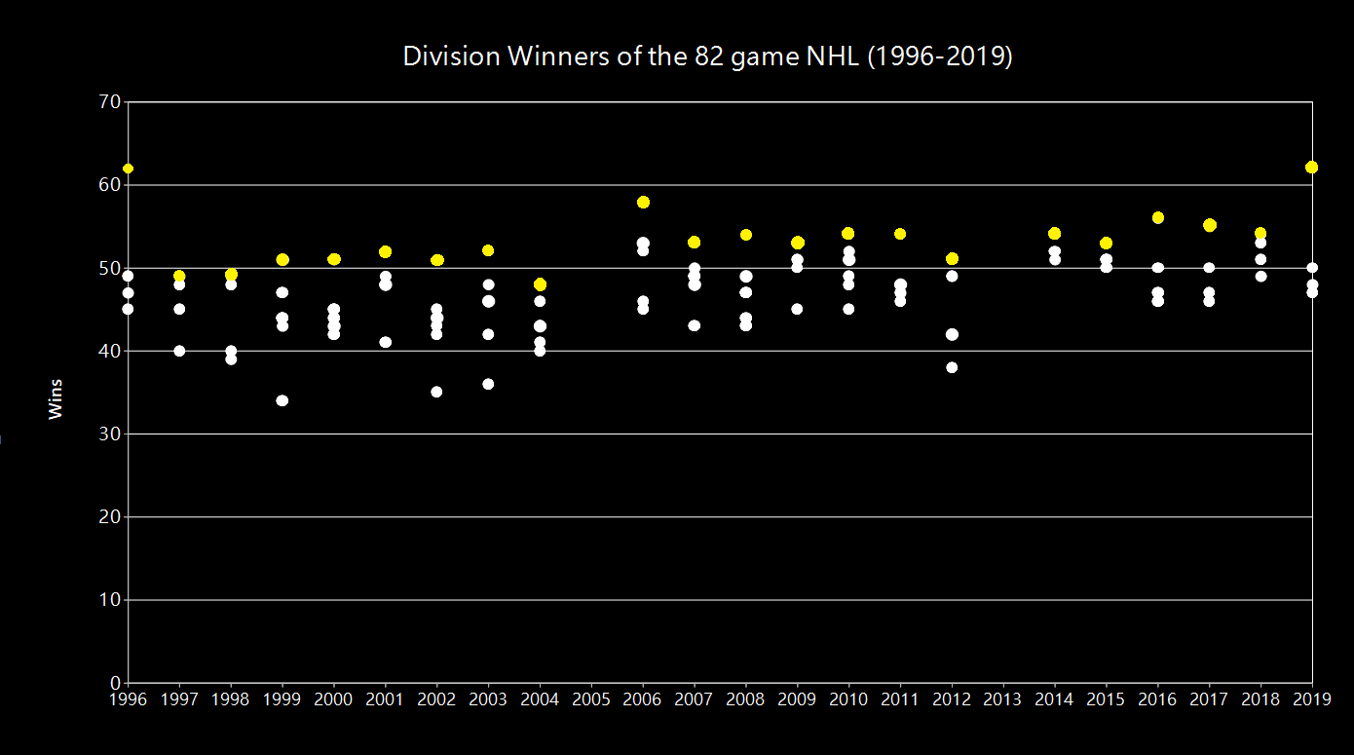
Winning the President’s Trophy means you has the most points of any team in the league. It’s not an easy thing to do. That’s because hockey is an unforgiving sport, and a changing landscape that can cause great teams to give up losses to opponents that they maybe shouldn’t. Of course, winning the President’s Trophy doesn’t guarantee you the Stanley Cup. In fact, quite the opposite.
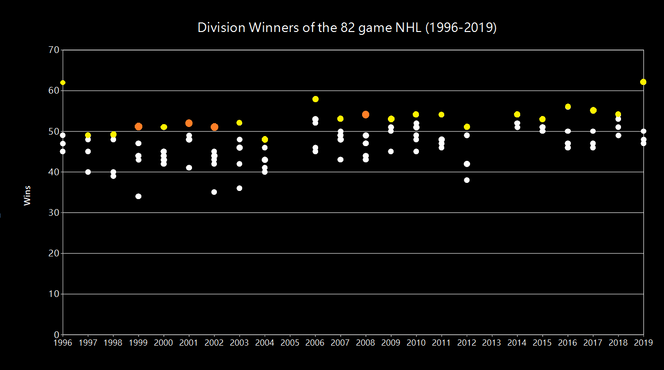
In this era, only four teams have won the President’s Trophy, and gone on to win the Stanley Cup. Well, five. The Blackhawks did it in 2013, but that season was shortened by the lockout. For our purposes, it has been omitted. So if the success rate is only four in twenty-one, who are the rest of these yellow dots? All these teams dominated the league, and then came up short when it mattered. Who were they?
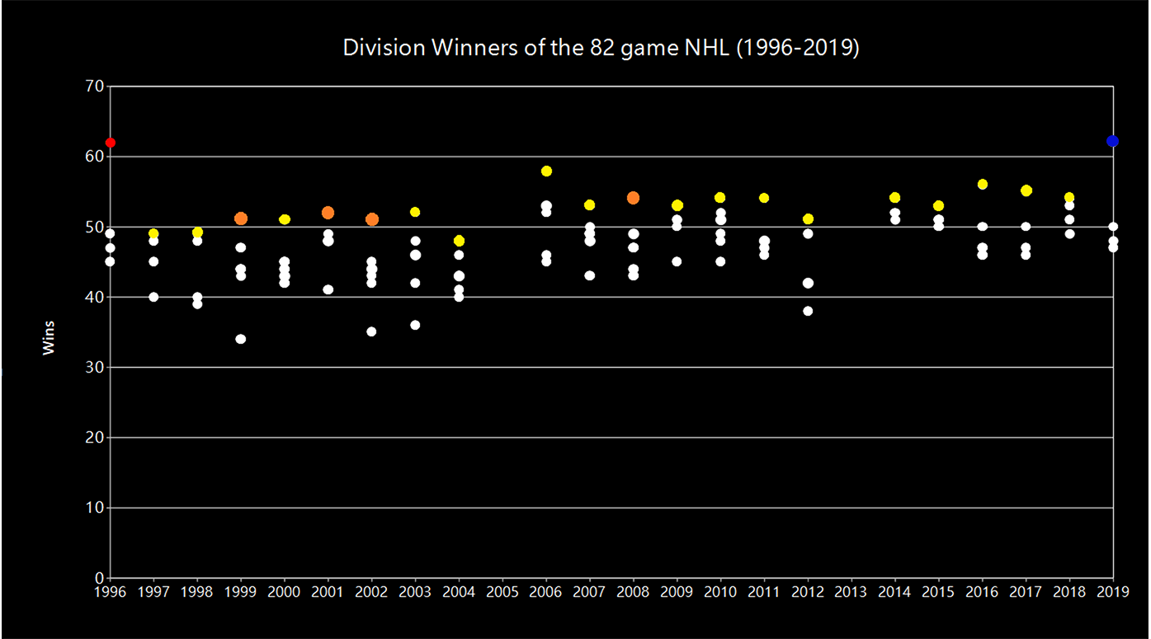
Who were these two?

Let’s start with the team that did it first; The 1996 Detroit Red Wings.
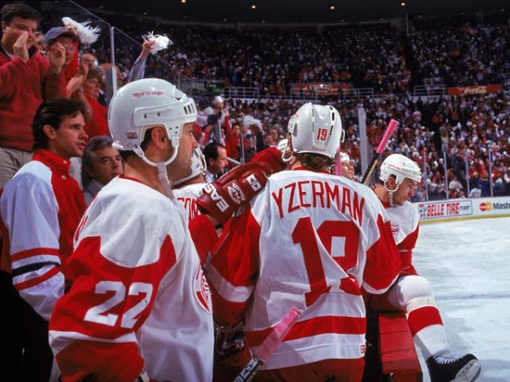
This Red Wings team marked the start of an empire. From the mid ‘90s onward, Detroit would be a juggernaut of a team. 1996 was the first year that this team broke into its own. They were absolute monsters in the league. The NHL of this time had 26 total teams, and 12 of them failed to knock a win off of Detroit. Of course, nobody had a winning record against them, the closest anyone came was the Winnipeg Jets, who took two wins and a tie away from the six games played between them. They were the only team to beat these Red Wings more than once.
NorEast | Record | Atlantic | Record | Pacific | Record | Central | Record
PIT | 49-29-4 | PHI | 45-24-13 | COL | 46-25-10 | DET | 62-13-7
BOS | 40-31-11 | NYR | 41-27-14 | CGY | 34-37-11 | CHI | 40-28-14
MTL | 40-32-10 | FLA | 41-31-10 | VAN | 32-35-15 | TOR | 34-36-12
HFD | 34-39-9 | WSH | 39-32-11 | MDA | 35-39-8 | STL | 32-34-16
BUF | 33-42-7 | TBL | 38-32-12 | EDM | 30-44-8 | WPG | 36-40-6
OTT | 18-59-5 | NJD | 37-33-12 | LAK | 24-40-18 | DAL | 26-42-14
 |  | NYI | 22-50-10 | SJS | 20-55-7

Meanwhile, plenty of other teams notched impressive seasons this year. The Penguins, for instance, won a pretty competitive Northeast division. It helps that they still carried the fading prime of Jaromir Jagr, Mario Lemieux, and Ron Francis, all of whom helped secure their back-to-back cups just a few years earlier. There were lots of good teams that played great seasons, but none of these efforts even scraped the heels of Detroit. The team just couldn’t be stopped, and they really were a team.
Sergei Fedorov
Forward (RW)
Sergei Fedorov was the Red Wings’ top forward this season. He had a great year, 39 goals, 68 assists, and low penalty numbers for a guy who played in almost every game. Furthermore, Fedorov was the top guy in the Russian Five. The Russian Five were a group of top players from the Soviet Union that coach Scotty Bowman had assembled for Detroit. He knew that these players all learned from Russian coaches “red army” style that dominated any international competition. The Russian Five’s story is a unique one on its own, and the eponympous movie about them is well worth a watch. All five of these players were stellar, and Fedorov was the standout among an already elite crew.
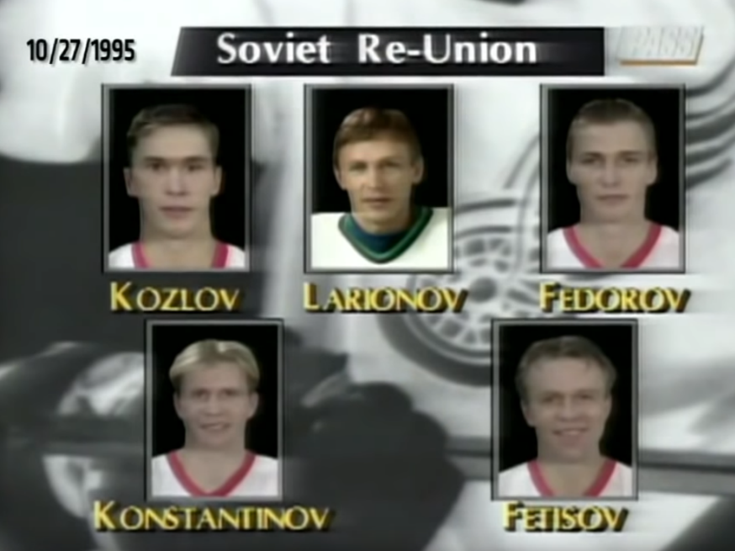
So, Fedorov had everything going for him. The best team in the league needed a top scorer, and he was just the one to do it. How did he fare?
 | Player | Team | Points | Goals | Assists
1 | Mario Lemieux | PIT | 161 | 69 | 92
2 | Jaromir Jagr | PIT | 149 | 62 | 87
3 | Joe Sakic | COL | 120 | 51 | 69
4 | Ron Francis | PIT | 119 | 27 | 92
5 | Peter Forsberg | COL | 116 | 30 | 86
6 | Eric Lindros | PHI | 115 | 40 | 68
7 | Teemu Selanne | WPG/MDA | 108 | 40 | 68
8 | Paul Kariya | MDA | 108 | 50 | 58
9 | Sergei Fedorov | DET | 107 | 39 | 68
10 | Alexander Moginly | VAN | 107 | 55 | 52

There’s our guy.
The Detroit Red Wings, without a single player scoring 40 goals, were the most unbeatable team in the history of hockey. Their entire roster put points in with incredible proficiency. They were 14 players deep of guys who scored double-digits. The many goals of these Red Wings were certainly a major factor in their success, but it all starts to fit together when you look at how they played games as a whole.
See, it was hardly just an offensive effort.

Here we can see the goal differential of every team this season. That is, the difference between goals scored and goals allowed. We can also see their goals scored per goals allowed, which will give us a sense of scale. There are “carbon neutral” teams like the Canucks, who scored exactly a single goal for every one they allowed. There are teams wallowing in abysmal seasons, like the Senators who went -100 and scored so infrequently that they only managed 0.65 of a goal scored each time they let one in.
And then there are the Red Wings.
All alone.
You’d be forgiven for missing them up in the top right, since they went +144. The distance between them and Colorado, the next highest, is 58. Nobody was in the same universe as them.
They were no slouches on offense, but their defense is what put this differential through the ceiling. Behind a league-lowest 181 goals allowed, this team scored nearly twice as often as they allowed goals. It’s completely unprecedented, but it makes a bit more sense when you look between the pipes.

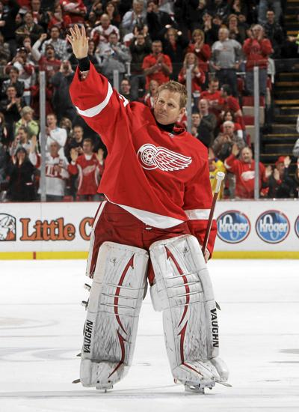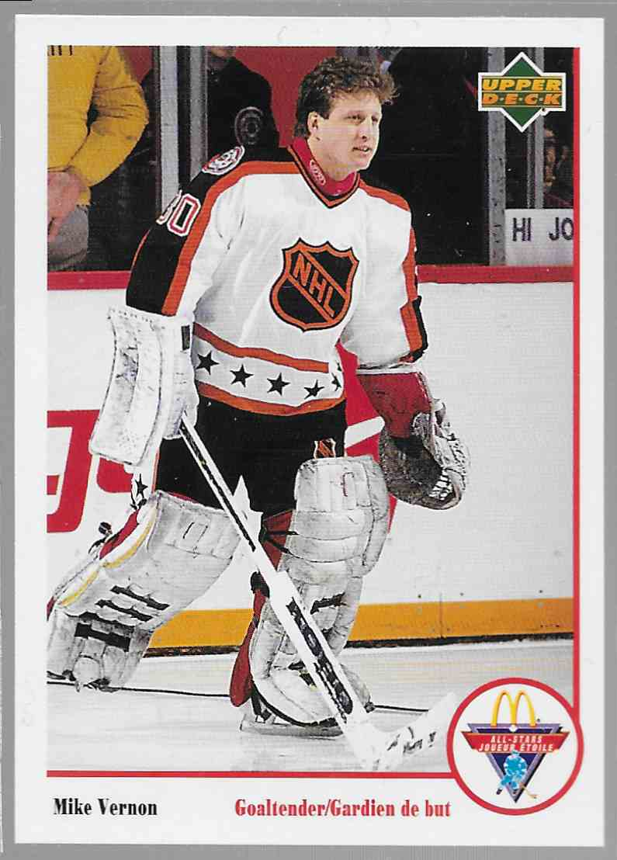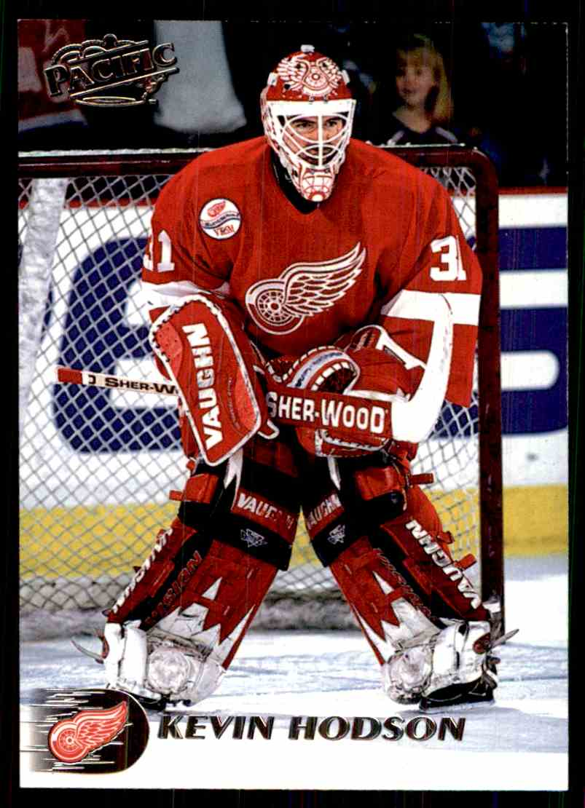
Chris Osgood | Mike Vernon | Kevin Hodson
GP - 50 | GP - 32 | GP - 4
SV% - .911 | SV% - .903 | SV% - .955
GAA – 2.17 | GAA – 2.26 | GAA – 1.16

The Wings’ goaltending core was stunning. What the team lacked in top-tier goal scoring, they more than made up for with these three men. Chris Osgood, who did not win the Vezina trophy, boasted the lowest Goals Against Average of any starting-caliber goalie in 1996.
Top 6 Starting* Goaltenders, 1995-1996
 | Team | GAA | Save % | Shots Faced | GP
Dominik Hasek | BUF | 2.83 | .920 | 2011 | 59
Daren Puppa | TBL | 2.46 | .918 | 1605 | 57
Guy Hebert | MDA | 2.83 | .914 | 1820 | 59
Ron Hextall | PHI | 2.17 | .913 | 1292 | 53
Martin Brodeur | NJD | 2.34 | .911 | 1954 | 77
Chris Osgood | DET | 2.17 | .911 | 1190 | 50
*Played minimum 50 games
I’ll let you watch some Osgood highlights on your own time, but they are truly worth watching. His reflexes were insane; shots that would blindside anyone else were caught with crazy proficiency. Breakaways that are all but guaranteed to score get kicked away at the last second.
Much less important, but far more interesting; Chris Osgood scored a goal. Goalies score in hockey when the other team leaves their net empty for an extra attacker. Not only does the goalie have to get control of the puck in this situation, they have to chip it the full 180 feet from net to net. For a brief, beautiful moment, hockey gets turned into golf.

Mike Vernon was no slouch, either. He ended up tying the Goals Against Average of the actual Vezina winner, Jim Carey. See, being a secondary goaltender is an unsung job. He played over a third of this season’s games, but Detroit is not his legacy. He’s best known as a goaltender for the Calgary Flames, where he posted a season with a confounding statistic that shows us how numbers fail.

It’s January, 1984. Oilers at Flames.
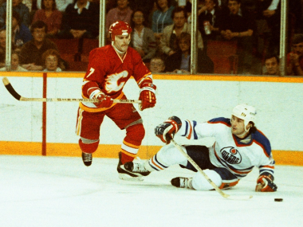
The Flames are getting absolutely trounced by Gretzky’s superteam from Edmonton. In what would eventually end in a 9-6 loss, a second year Mike Vernon would come in relief during the first period. It was his third game in the NHL, and he had everything to prove.
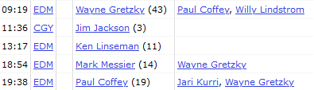
Whoops.
This was the only play that Vernon saw in the entire 1984 season. He only blocked two shots, and gave up four goals in just less than eleven minutes. There are two reasons that these eleven minutes are infamous. First is that Vernon was absolutely terrible at the start of his career, but as we know he got a lot better. The second reason is thanks to math. Goals Against Average is a fairly useful statistic for any goalie that plays regular minutes. It gives you a sense of about how many goals they allow per game. It’s a bit unreliable but still used a lot anyway. It’s calculated with this fun equation:
(Goals Allowed x 60) / Minutes Played
So let’s just go on ahead and plug in Vernon’s numbers…
(4 x 60 = 240)
240 / 10.97 = 21.877
21.877 GAA
Oh dear, Mike. That isn’t very good.

 |  | GA | Save% | Time Played
@ Penguins | L | 1 | .929 | 28:02
vs Blackhawks | W | 0 | 1.000 | 60:00
vs Kings | W | 2 | .926 | 60:00
vs Sharks | W | 0 | 1.000 | 15:14

These are the 4 lonesome games played by third-rotation goaltender Kevin Hodson.
If being a backup makes someone underappreciated, being a third-rotation means you’re practically invisible. But to overlook Hodson would be to ignore some truly excellent games. This was his first season in professional hockey, and it seemed like he was just here for the ride. When he was called upon, though, he stood tall among his peers. His first appearance came in January, versus Pittsburgh. Chris Osgood had just given up four goals in six minutes to the explosive offense of the Penguins. So, Hodson got his chance, and only gave up one goal in the remaining half of the game. His team couldn’t reward him for this effort, but the next day, he didn’t need anybody else’s help.
24 hours after Hodson had weathered the best offense in the NHL, he had earned a start against the Blackhawks. These Hawks were a great team, and division rival of Detroit. Their roster touted guys like Chris Chelios, a future hall of famer, and Bob Probert, who earned his reputation as the scariest enforcer in the league thanks to a few seasons with the Red Wings themselves. They were as close to an equal as Detroit had in the Central Division, and Kevin Hodson shut them out. Of course, this was only one of four games that Hodson played in, and he never really got his time in the league to be somebody’s #1 guy. What he was, for a few brief flashes in January of 1996, was a player that embodied his team; Defiant, unlikely, and yet unstoppable.
So who stopped them?
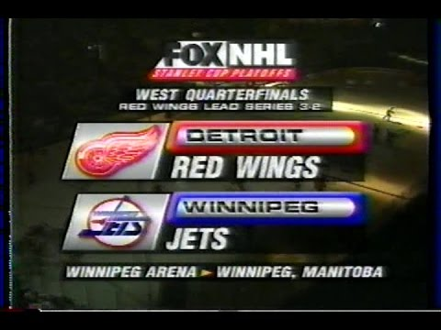
Detroit’s first round opponent was the Winnipeg Jets, the aforementioned only team that gave them any kind of trouble through the regular season. The Red Wings handled them, though. The two teams traded uneventful wins at home until Game 4, until the Jets were embarrassed at home with a 6-1 defeat courtesy of six different goal scorers for the Wings. Winnipeg responded with their own road win, and then ultimately lost the series at home in Game 6.
The Jets’ fateful playoff defeat was the last game they would play in Winnipeg for 15 years. That summer, the team announced they were moving to Arizona as part of the league’s efforts to expand their US markets. Losing to Detroit wasn’t the direct cause, but it certainly sealed their fate.
The best team in the league looked like they were just getting started.
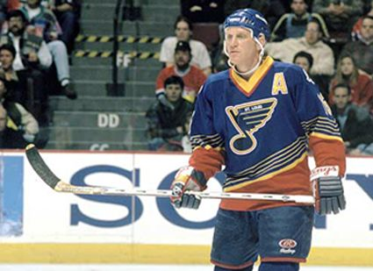
The Red Wings had a job to do, and the Blues would do their best to slow them down. When these two teams met in 1996, the Blues were in the midst of an era of success. They were hard at work keeping up their playoff appearance streak (which ended at 25 consecutive in 2004), and their roster was headlined by two of the best players of all time; Brett Hull, and Wayne Gretzky. Detroit, though, came to play. This was a great series fueled by explosive goal scorers. In the seven game series, there were 38 goals scored by both teams combined. It came to an incredibly dramatic head, too.
May 16th, 1996. The seventh and final game of the Western Conference Semifinal, being played in Detroit. This series has been marked by some obscenely high-scoring games, and yet the first period comes and goes with each team holding fast. So many of the players that skate tonight will be inducted into the hall of fame, ascended as some of the best hockey players of all time. Second period, no scoring. The Wings absolutely crushed the regular season, and St. Louis made it to a showdown with these supernaturally skilled players, despite landing 4th in their division. The third period comes up dry. It’s overtime. This series has been grueling, no surprise given how tight these teams’ regular season games were. The first overtime buzzes complete. As the exhausted players trot back out to start the fifth period of the night, everyone is wondering how long it’ll drag on for.
Not that long.
“Gretzky had it, lost it, Yzerman picks it up.”
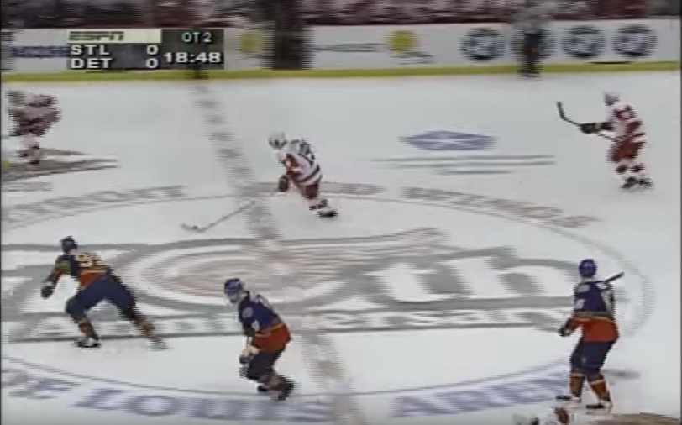
“Yzerman moving, blue line chance-“
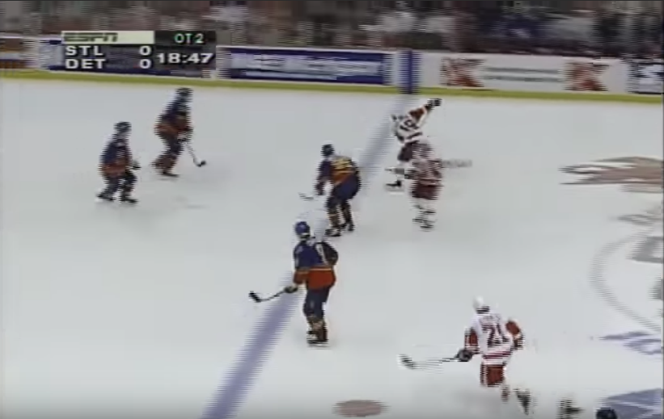
“SCOOOOOOOOOOOOOOOOORE”
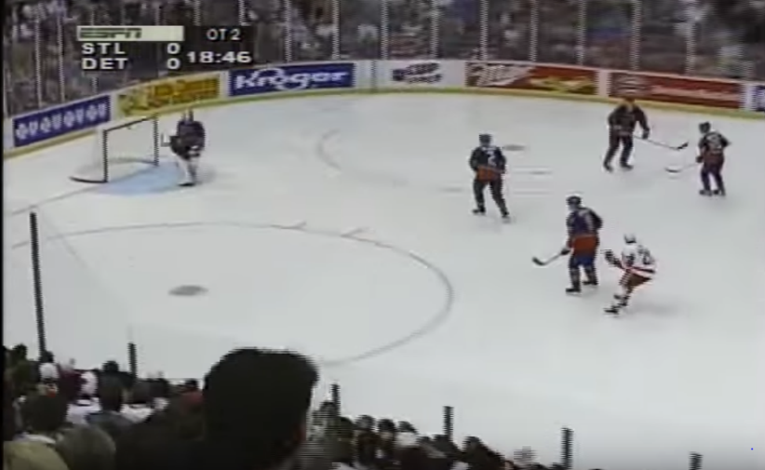
“STEVE YZERMAN!”
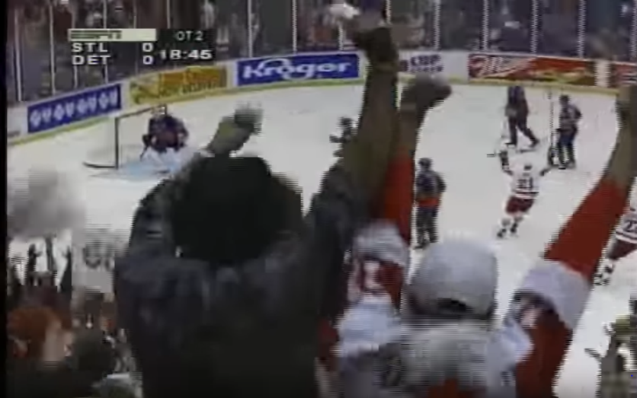
“DETROIT WINS!”

This double overtime goal was scored in front of a home crowd that hadn’t seen their team lift the Cup since 1955, a period known as the “Dead Wings” era. More than forty years in the making, and the man who put them one step closer was the captain himself. Steve Yzerman will come up again later, much later. For now, though, he is a hero. He has sent his team, who already achieved a historic landmark, into the Western Conference Finals. Their opponents awaited them.

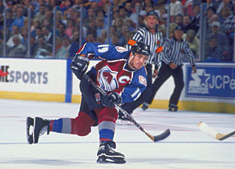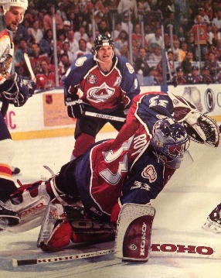
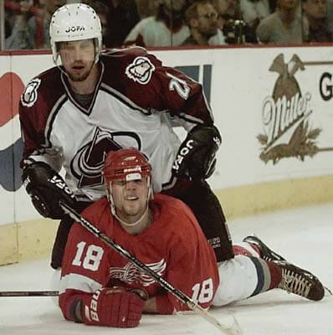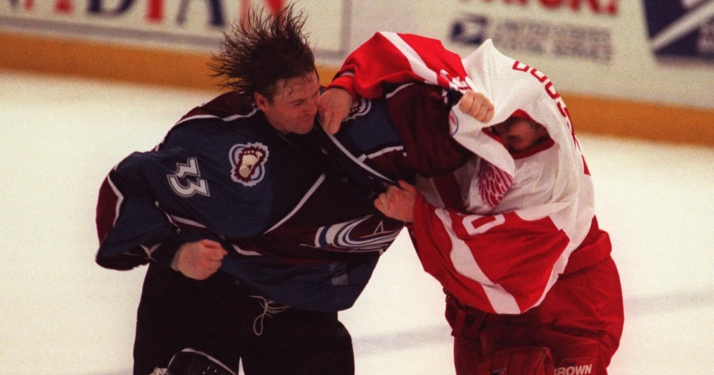
It’s finally time to talk about the Colorado Avalanche. First and foremost, was the fact that the Avalanche were brand new. Over the summer of ’95, the Quebec Nordiques officially moved from Quebec City, Quebec, to Denver, Colorado. The Avs were in the Pacific Division of the Western Conference, with the Red Wings over in the Central. It allowed Colorado to take advantage of their talent and win their own division. Talent which, by the way, was inadvertently supplied by Detroit.
December 2nd, 1995. The Red Wings are playing in Montreal, and running circles around the Canadiens. Patrick Roy, Montreal’s star goalie, is being left out to dry by his coach. He’s playing horribly, he would be the first to tell you that, but the bench is denying his pleas to pull him from this game. Detroit refused to relent on the unfortunate netminder, racking up 9 goals before Roy was mercifully allowed to leave the crease. Incensed by the stubbornness of his coaching staff, Patrick Roy walked right up to Canadiens President Ronald Corey and told him, “That’s my last game in Montreal.” Sure enough, Roy requested to be traded, and he quickly found himself with a new home; Patrick Roy was now a proud member of the Colorado Avalanche. Roy was just one piece of an Avalanche team that was incredibly strong through the season. They won their division, and made the playoffs with ease. They were on a crash course with Detroit, taking down the Canucks in 6 games, then the Blackhawks, once again in 6. They were waiting comfortably to see whether they would face the Red Wings or the Blues, and when Steve Yzerman sent his team to the Conference Final, he changed the futures of Detroit and Colorado for years to come.
But this wasn’t the future. It was the present.
And in the present, they just couldn’t do it.
The Detroit Red Wings, after playing an unfathomably good season, couldn’t do it. The Colorado Avalanche beat them in 6 games. It was a dramatic series, with some excellent games played by both sides. They both had everything to prove; A Red Wings team out for blood after they had come short in the cup final just a season prior; And the Avalanche, who needed success to win over the city they had just moved to, not to mention Patrick Roy wanting to prove that his decision was the right one.
What makes this series legendary, though, was the hit that started a blood feud.
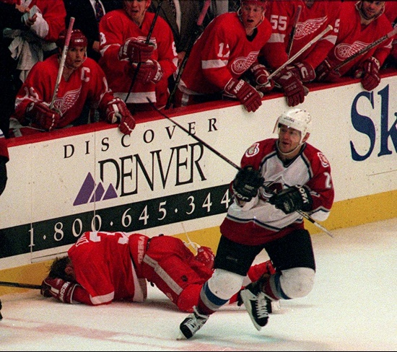
In the sixth and final game of this series, Claude Lemieux of Colorado came and checked Kris Draper in front of his own bench. Draper’s face went straight into the edge of the bench. He suffered a broken jaw, nose, cheekbone, and a concussion. It was completely unnecessary. You can watch the footage and see that Draper already ditched the puck. Not to mention that Lemieux blind-sided him in front of his own bench, both things that are looked down upon by players. Even in the era of the enforcer, it was too far. So it was a dirty hit deep into the playoffs, that’s normally enough to cause some scuffles, but this had some extenuating circumstances. Lemieux didn’t apologize; Not to Draper, not to the Red Wings. On top of this, the hit happened in the most bitter loss Detroit could have ever imagined. The series-losing Game 6, in a playoff bracket that they were odds-on favorites for, after the greatest season of hockey that would be played for the next 23 years.
It was perfect, in a way. The bigger they are, the harder they fall. This Detroit team was as big as they come.
The 1996 Detroit Red Wings were without equal, and yet they failed in the end. Their fate was still in their own hands, though. They finally got their cup the very next year, this time cutting down the Avalanche in another bloody Western Conference Finals. Everybody had forgotten how good the team was just a year prior, because that team had failed. 62 wins was an absurd metric, but failing to win the cup burned that legacy to the ground. Everyone remembers the names etched in silver, not the ones written in the record books. That is, until someone just as good comes along and threatens to topple legends.

It took 23 years for that someone to emerge.

October 10th, 2018.
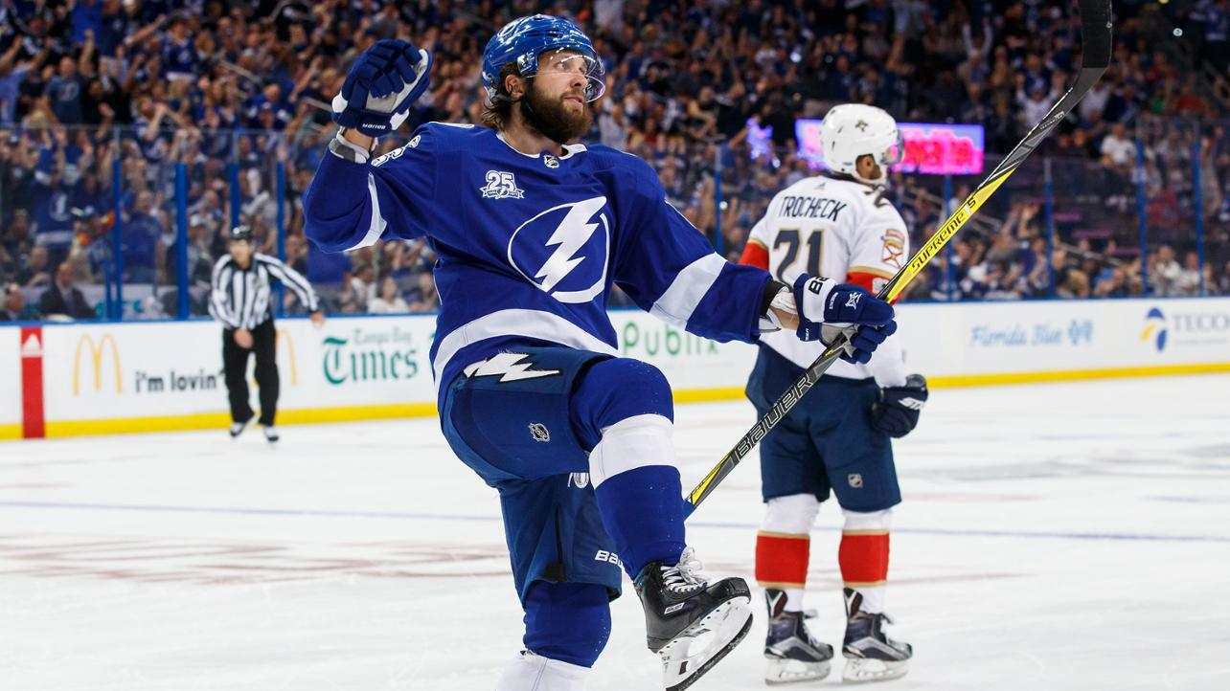
The Tampa Bay Lightning started their ’18-’19 campaign with a win against their state rivals, the Florida Panthers. It was a great win, the kind of start that Tampa needed to get back on their feet. Just months ago, the Lightning choked away a 3-2 series lead against the Washington Capitals. That 2018 Eastern Conference final was just pitiful for the promising team; They failed to score a goal in both Game 6 and Game 7, hardly even putting up a fight as the Caps recovered en route to a Stanley Cup. So when the clocks reset, and the dust settled, the Lightning wanted to prove that they could put it all together.
They did.
If Detroit was a team that succeeded without a clear-cut superstar, then Tampa Bay were their polar opposites.
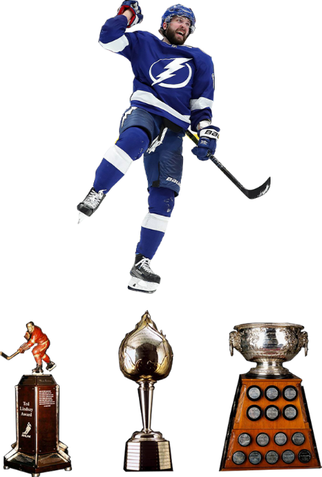
Nikita Kucherov
Ted Lindsay Award Winner
Hart Memorial Trophy Winner
Art Ross Trophy Winner
#1 In points in the NHL (128)
#1 In assists in the NHL (87)
#6 In goals in the NHL (41)
Now, to say that Kucherov was the Lightning’s only good player would be completely disingenuous. What’s important, though, is that Tampa Bay had their ace. Kucherov was one of just many players that made this roster absolutely legendary, guys like Steven Stamkos, Brayden Point, and Victor Hedman, could all score like machines.
If a team was going to repeat the insane accomplishment of the ’96 Wings they were going to need a top goaltender. Teams in the 2010s were in an absolute arms race to get the best goalie on the planet, and Andrei Vasilevskiy was just the guy to go nuclear.

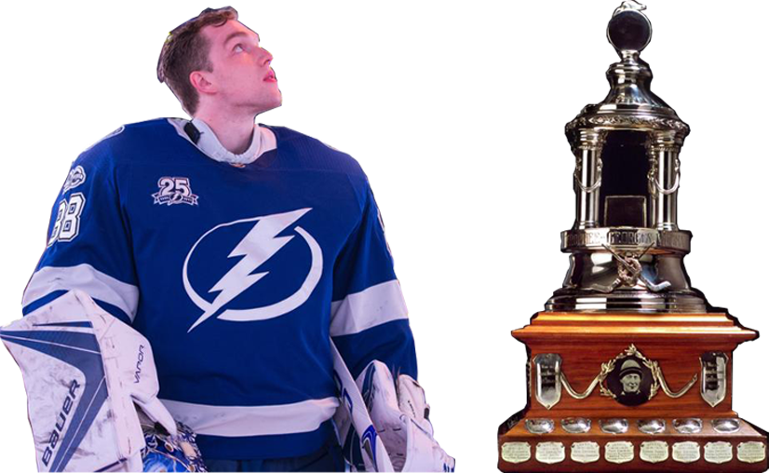
Andrei Vasilevskiy
Vezina Memorial Trophy Winner
Save Percentage - .925
Goals Against Average – 2.40

I’ll concede that Vasilevskiy might not have been the top goalie by numbers. However, what he did to earn the Vezina trophy was something more important than numbers; He was a rock. He was the number one guy, on the number one team. Winning against the Lightning always seemed out of reach for their opponents. When they got a lead, they were untouchable. This season was infamous for teams losing leads, in part because goalies got too comfortable for their own good. Teams had a hard time holding out when they were ahead. Not the Lightning.

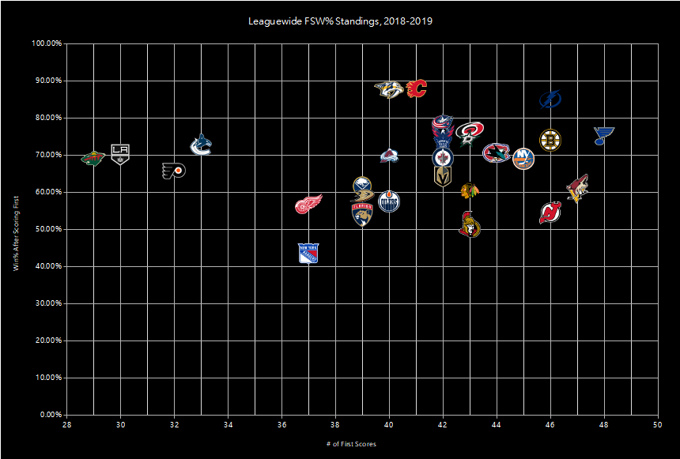
What you’re looking at is the First Scoring Win Percentage results for every team in the ’18-’19 season. The crisis of holding leads was most pronounced at the start of the season, skeptics in the news media began to call this some kind of a curse. If you scored first, you were probably going to lose. So, I wanted to know if that was true. Here we see the results of two things: Number one, did the team score first? The more they scored the first goal of a game, the more they are to the right. Number two, did they win after they scored first? If they do, their percentage goes up, and their logo moves north.
Now, overwhelmingly, scoring first was not a curse. Only two teams performed at or below 50%, the Rangers and the Senators. This data is incredibly interesting to me, and there’s a fascinating story in every case here. A few personal favorites are the Devils, who scored first in more than half of their games, but it just didn’t matter when they did. Nearly opposite of that are the Wild and the Kings, who barely ever netted the first goal of a game, but who did pretty well for themselves when they did. Nashville and Calgary are both at the top of this chart, but their sample of scoring means they did so in fewer than half their games. Tampa are pretty high up there, so how did they do on the whole year?
As if you expected anything different.
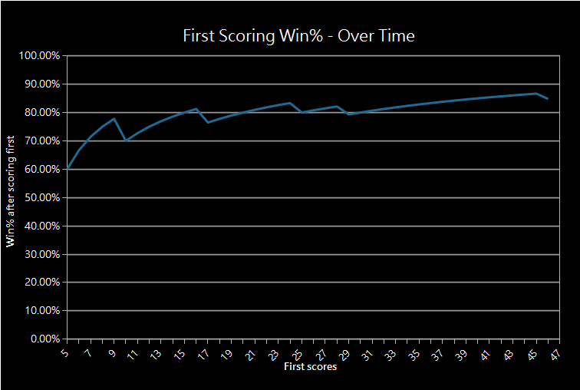
This chart tracks the Lightning’s First Score Win% over the course of the whole season. This sample starts after they net the first goal 5 times, that way we get to see a decent sample size by the time our graph starts. Now what the graph doesn’t tell you is that it took Tampa only seven games to score the first goal five times. This meager feat took some teams over a month, and the Lightning did it about a week and a half before Halloween. This slope is as simple as they come, they tended to score first, and they were tremendously good at holding that lead. By the end of the season, they had almost an 85% chance of winning if they scored the first goal.
But what if they scored three?
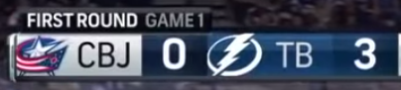
We’re getting ahead of ourselves, though. While we’re still with the first scoring data, I want to show you something else that proves how hard the Tampa Bay Lightning were to beat.
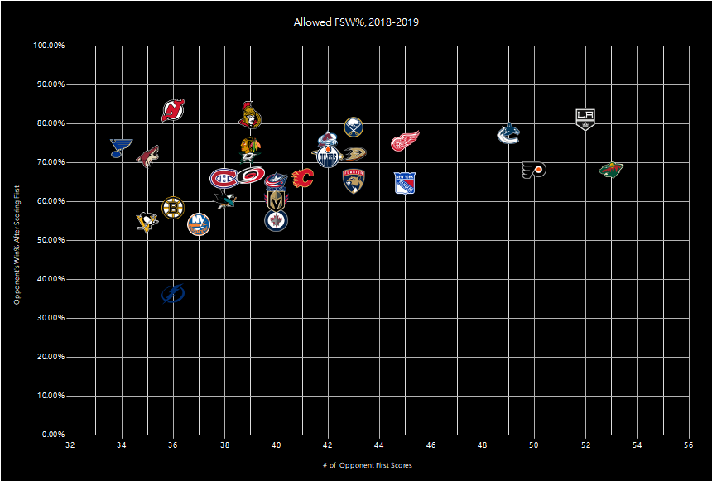
This chart shows the inverse of what our other one did. This looks at how teams did when they got scored on first, and how often they allowed their opponents to put the first one in. Lots of these are just sad, once again we can see the Kings, who let in way more than they netted, and then tended to just roll over. The Devils were absolutely terrible at coming back, but as you’ll remember they weren’t superstars when they did it first themselves. What’s remarkable, though, is that everyone in the NHL seems to lose more than they win against opponents that score first. Well, almost everyone.

We cannot ignore this. Tampa Bay were the reapers. They were the curse, in the form of the most profoundly unbeatable hockey team on the planet. When the Tampa Bay Lightning scored first, they could not be stopped. When you scored first, the Lightning didn’t care. They were never meant to lose. How do you beat a team that isn’t meant to lose?
Atlantic | Record | Metro | Record | Central | Record | Pacific | Record
TBL | 62-16-4 | WSH | 48-26-8 | NSH | 47-29-6 | CGY | 50-25-7
BOS | 49-24-9 | NYI | 48-27-7 | WPG | 47-30-5 | SJS | 46-27-9
TOR | 46-28-8 | PIT | 44-26-12 | STL | 45-28-9 | VGK | 43-32-7
MTL | 44-30-8 | CAR | 46-29-7 | DAL | 43-32-7 | ARI | 39-35-8
FLA | 36-32-14 | CBJ | 47-31-4 | COL | 38-30-14 | VAN | 35-36-11
BUF | 33-39-10 | PHI | 37-37-8 | CHI | 36-34-12 | ANA | 35-37-10
DET | 32-40-10 | NYR | 32-36-14 | MIN | 37-36-9 | EDM | 35-38-9
OTT | 29-47-6 | NJD | 31-41-10 |  |  | LAK | 31-42-9

The mad men had done it. 62 wins. The 1996 Red Wings finally had an equal. It took 23 years, and a team this good was finally ready to blaze a path deep into the playoffs to win the cup. As the dust was settling on the 2019 season, there was a question to be answered: Who would be the poor saps to have to play Tampa?
Columbus Blue Jackets
47-31-4
Last team to clinch playoff berth in 2019
Franchise playoff series record: 0-5

Regular season results between Tampa Bay and Columbus
Oct. 10, 2018 | Lightning @ Jackets | Tampa Bay Victory | 5-1
Jan. 8, 2019 | Jackets @ Lightning | Tampa Bay Victory | 4-0
Feb, 18, 2019 | Jackets @ Lightning | Tampa Bay Victory | 8-2

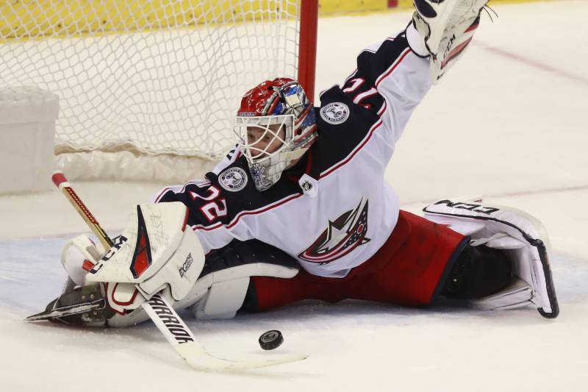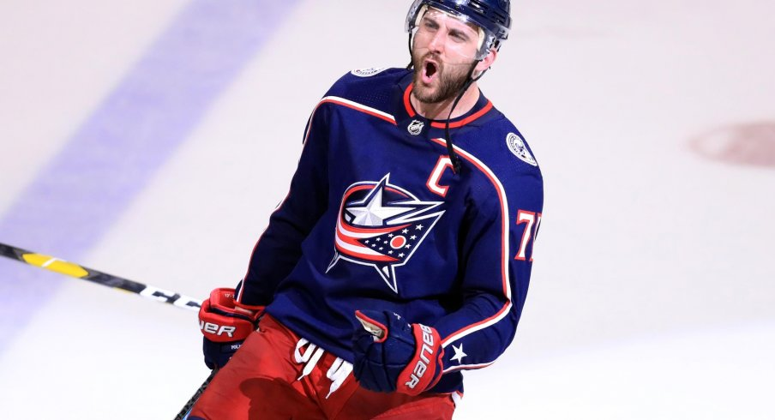
The Columbus Blue Jackets had such an interesting year in 2019 that it was a shame when they drew the Lightning as their opponent. They had so many ups and downs that you may as well have flipped a coin to predict the outcome of a game. They still made it, though, and they were strong. On paper, their roster was stacked up with mid-tier guys who could just never manage to stand out. Then, leading right up to the trade deadline, the Jackets made moves to bulk up for the playoffs. They hadn’t even clinched a spot yet, and the management went all-in for three key players.
Matt Duchene | Ryan Dzingel | Adam McQuaid
Forward (C) | Forward (C) | Defenseman
Acquired from: Ottawa | Acquired from: Ottawa | Acquired from: Boston
50 Points as of trade | 44 Points as of trade | 5 Points as of trade
This was a clear act of loading up for the playoffs, and it filled some important holes that the Jackets’ roster lacked: Consistent scoring, and seasoned defensemen. The goal scorers are clear choices, easily two of the best forwards on the market at this time. Adam McQuaid seems odd, but makes tons of sense in context. For the majority of the season, Columbus’ top blue line pairing was Ryan Murray and Seth Jones. Then, after his performance on February 18th, Ryan Murray was sidelined with an undisclosed injury. This threw the talented Zach Werenski into the top pairing, and left the Jackets with a hole in their bottom four defensemen. Adam “’Splodey Bones” McQuaid was the perfect guy.
But I digress. The Jackets were loaded up, they clinched playoff berth, and quickly found themselves mathematically guaranteed to play the Tampa Bay Lightning. Everybody pitied these Jackets. They had just went all-in to make a playoff run, and then they found themselves running into an unstoppable freight train.
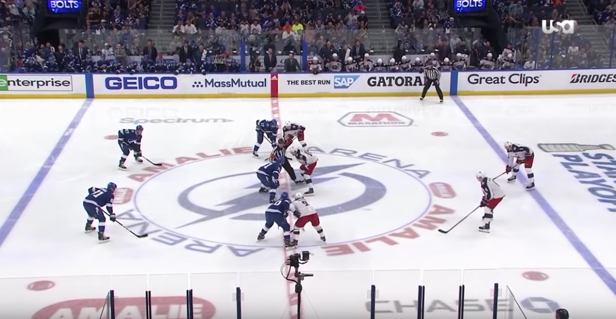
Eastern Conference Quarterfinals – Game 1
The Lightning wasted no time proving why they deserved to be here. Less than five minutes in, Seth Jones had an unlucky giveaway while Columbus was on the power play. Alex Killorn, who had been with Tampa Bay since 2012, took the breakaway and notched the first goal.
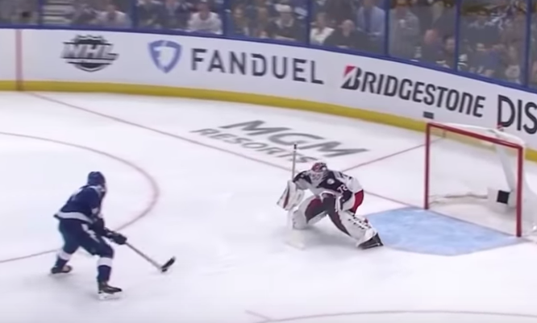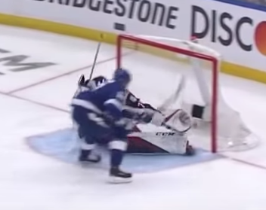
1-0 for the home team, and an 85% chance of winning. Things were going as planned, and then they did it again. This time from rookie Anthony Cirelli.
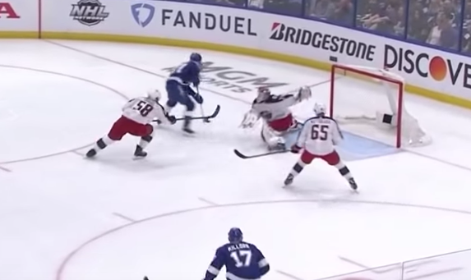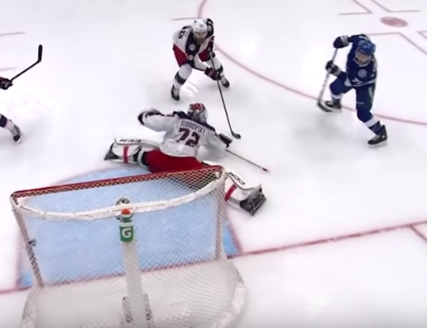
And then one more. Because Tampa has no chill, and completely terrorized every team they could. The game hadn’t even left the first period when Mikhail Sergachev scored the 3 – nothing goal to put the Lightning ahead.
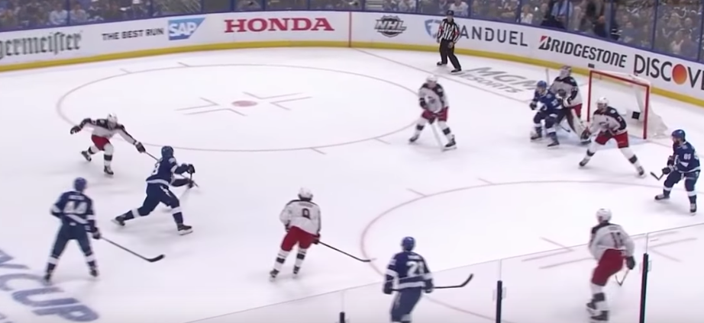
3 – 0. Tampa had not given up any such lead the whole season. There were a tiny handful of two-goal leads that the Lightning lost, but never up by three. Tampa, by the numbers, were virtually guaranteed to hold this lead, and start proving that they were truly number one.
So what happened?
For Columbus to win this game would be entirely unprecedented. Their opponents had never blown a lead this big. They rarely lost at home. And the Jackets, as a franchise, were starved of any kind of remote success in this venue. I would be completely remiss if I told you this story without mentioning the locker room speech. Media only caught about 30 seconds of it on video, but the pep talk given by John Tortarella after the first period is simply legendary.
“…Forget about skills, forget about X’s and O’s, it’s a [expletive] mindset of [expletive] believe it. It’s amazing what can [expletive] happen. So you [expletive] stand in there. You stand in there and you don’t take a [expletive] backwards step, not for a [expletive] second. It’s a great [expletive] opportunity to stand right [expletive] face to face with them, and go right [expletive] to them. There is no one taking a [expletive] backstep here. Alright, let’s (unintelligible).”
-John Tortarella, minutes after losing the 1st period 3-0
Nobody will ever know if that speech made Columbus win this game. You can’t look at inspiration on a spreadsheet. Team morale isn’t measured by a corsi number. What we do know, is what happened after that speech.

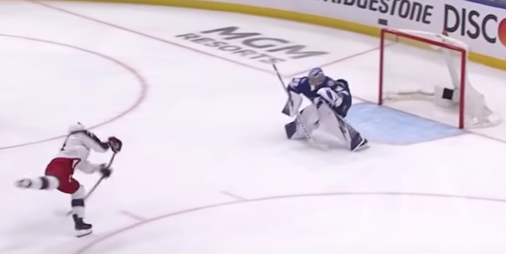
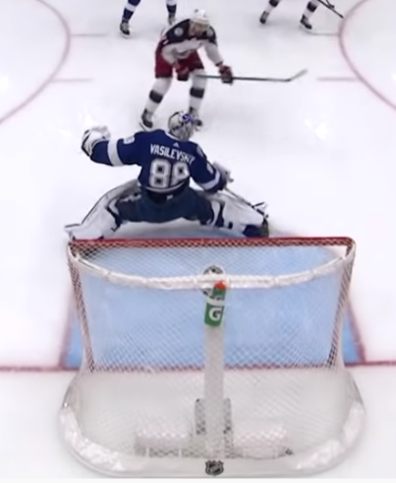
One. From Columbus’ captain himself.
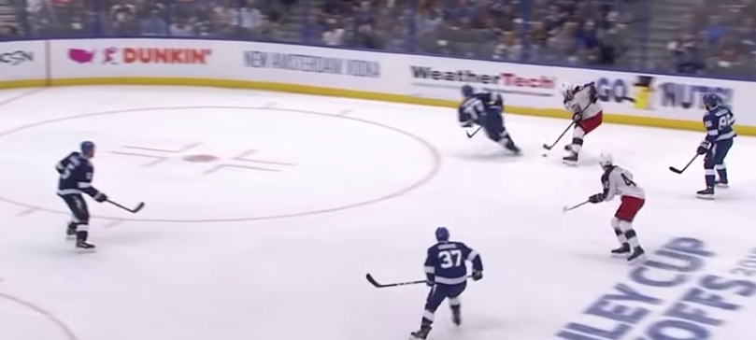
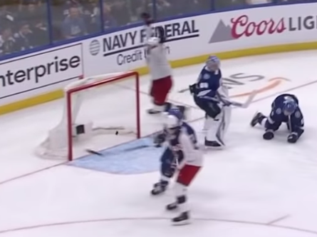
Then David Savard deked four guys, and made it 2-3.
What followed was a play that almost looks rehearsed. Columbus’ Brandon Dubinsky got caught for a High Sticking penalty- a double minor. The Jackets, who had an excellent penalty kill all season, managed to burned just two of the four minutes off the penalty clock. And then, Josh Anderson picked up a recovery pass from Boone Jenner. With no one down the left wing, and Savard picking up speed to his right, Josh Anderson went for it.
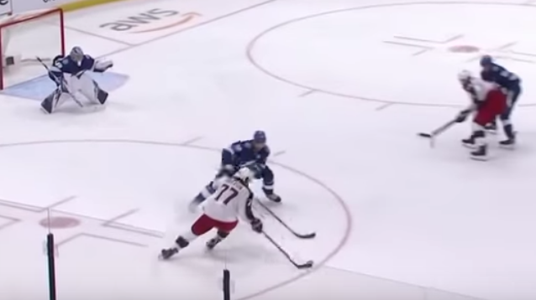
This play, seen above, is supposed to get stopped nine times out of ten. Normally the defenseman just cuts in and prevents his opponent from skating around him. Victor Hedman, Norris Trophy runner-up, did not do this.
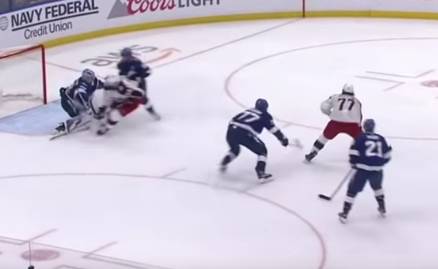
Anderson’s still got the puck, because both he and Savard knew that Steven Stamkos, the Lightning’s captain, was all over David Savard. There was no way for him to take a pass, but Stamkos was at his side. If he had enough speed, he could get in front of Vasilevskiy to get a screen on him. It worked like a charm, and Anderson took the shot.
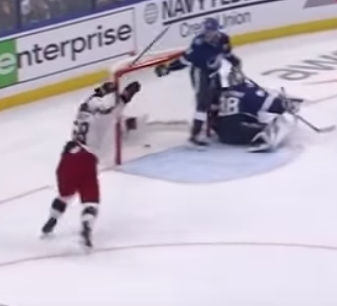
Tie game.
The Lightning could not breathe. Less than two hours ago, they were on top of the world; One of the greatest teams in the history of hockey, and up three goals to nothing on an opponent that was supposed to roll over and die. The Blue Jackets would do no such thing.
Frustrated, mere seconds after the Lightning had lost their lead, Alex Killorn took his own high sticking penalty. Thanks to the nature of penalties in the NHL, the teams would play about a minute of 4-on-4, giving Columbus just over 50 seconds of time with a man advantage. All Tampa had to do was stop the bleeding for 50 seconds.
They couldn’t.
Columbus executed one of the most straightforward powerplay maneuvers imaginable, which is remarkable given that they had one of the worst rates of capitalizing on penalties in the league.
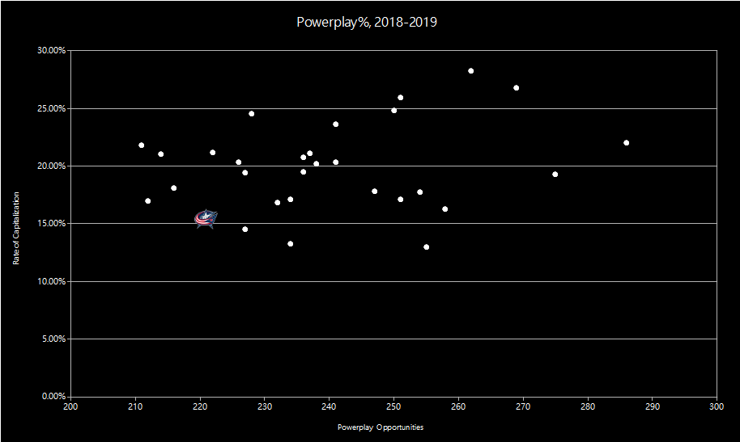

The Jackets could only manage this. It’s even more bizarre, when you consider that their opponents, the Lightning, had the absolute best penalty kill in the entire league.
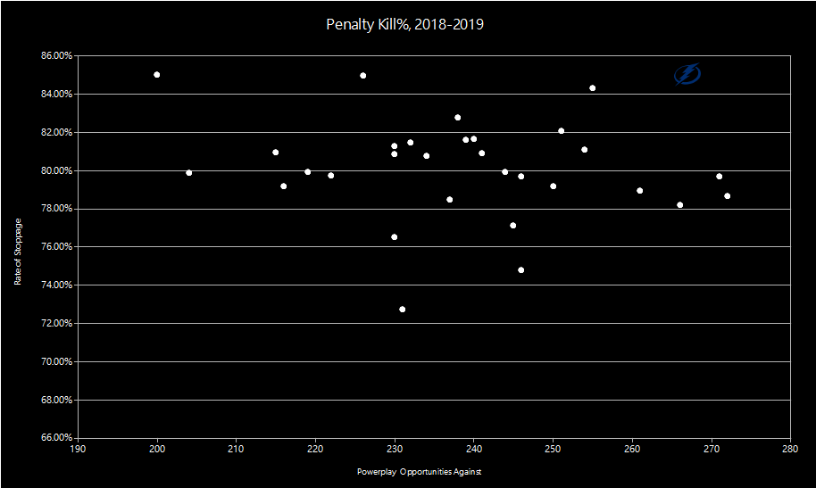
Tampa were rock solid when they were on the PK. The Blue Jackets were terrible when they had an extra man. They were going to be fine
So how on earth did this happen? 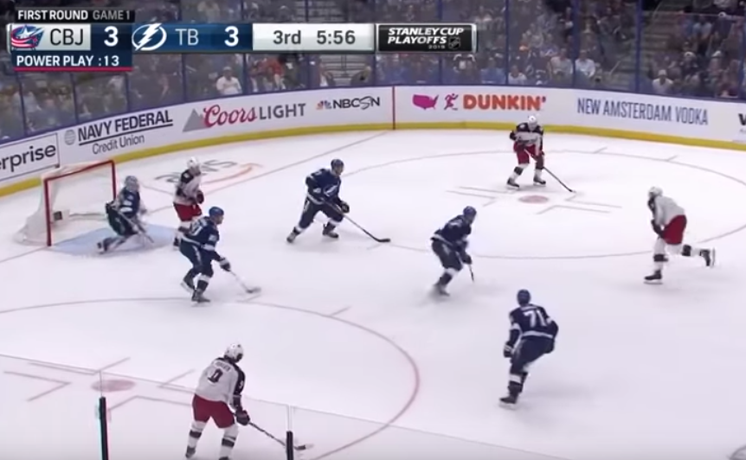

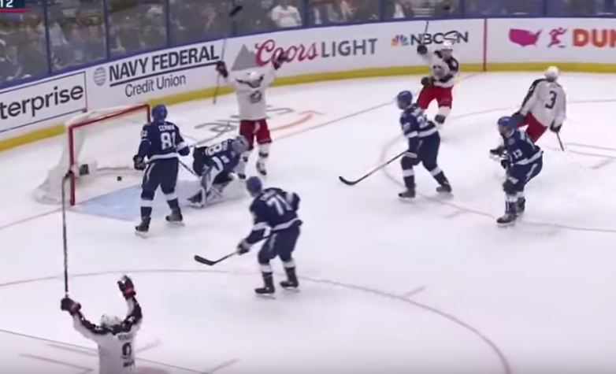
I dunno. I mean really, who does know? The most winning team of the 21st century blows a 3-0 lead, to the least winning franchise in the NHL. It makes almost no sense, and yet we can break it down to understand it completely. Tampa Bay lost that game, and felt embarrassed. Maybe they underestimated their opponent. Maybe the coach wanted to try something new. Or maybe, a team that had experienced almost nothing but winning for 6 months didn’t know what to do when they started losing.
Wednesday, April 17th, 2019.

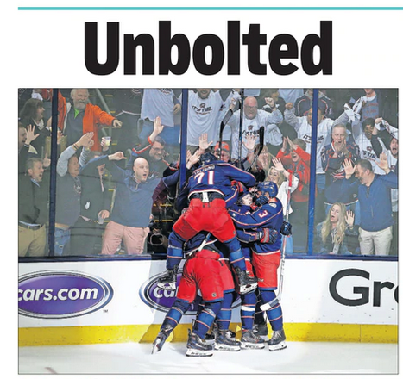
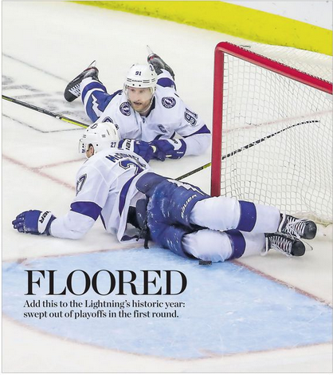
The Tampa Bay Lightning were swept out of the first round by the Columbus Blue Jackets. Four games to none. We were living in the twilight zone, this was not supposed to happen. The 1996 Red Wings had lost deep into the playoffs to the only opponent truly worthy enough to knock them down. In 2019, the Tampa Bay Lightning did what the Blue Jackets were supposed to; They rolled over, and died. Detroit before them had lost after proving that they could at least do something. The Lightning weren’t so lucky.
They didn’t lose after dispatching a gauntlet of worthy opponents.
They didn’t go back and forth in gritty, intense series.
There was no rise before the fall.
There was only the fall.
The story of the Tampa Bay Lightning is yet to be finished. As of this writing the team still has most of that core team from 2019. Hell, Detroit won three cups with their same core team that won 62. If you’re reading this in the future, you probably know more about their fate than I do. But for the time being, there’s still more to be written for this team.
When the dust had settled, and the 2019 season ended, everyone began drawing connections between Tampa’s accomplishment and the ‘96 Red Wings’. In truth, I think there are only two things that they share. The first, is that number. 62 wins. And the second, is Steve Yzerman.
Steve Yzerman
Hockey Hall of Fame Inductee
3x Stanley Cup Winner
1514 Games played
Steve Yzerman is one of the most legendary players of all time. He spent his entire 22 year career in Detroit. He was part of their 1996 team, and went on to win three Stanley Cups with them. In 2006, Steve finally hung it up. When his playing career ended, he stayed on with the Red Wings in the front office, and established a great reputation as he kept Detroit’s playoff streak alive. Then, in 2010 Steve Yzerman accepted a job from the Tampa Bay Lightning as General Manager.
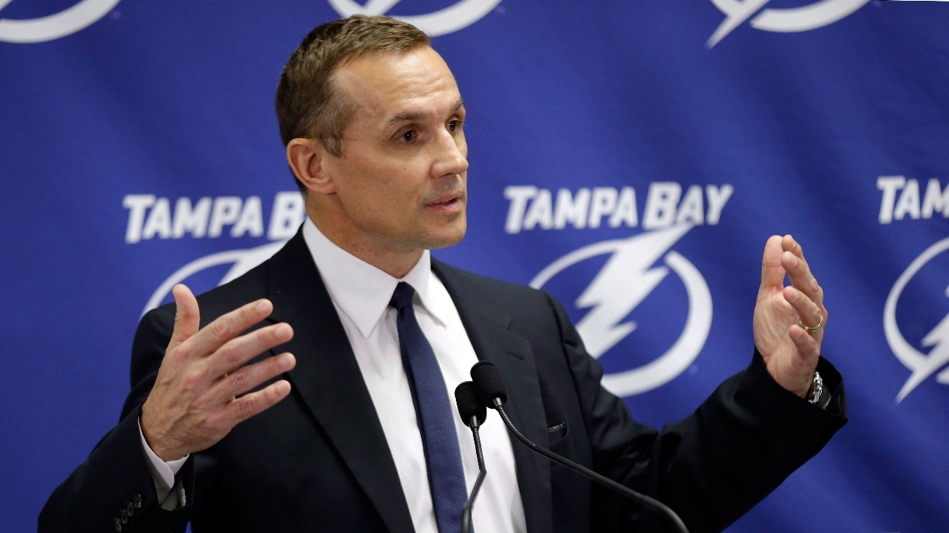
Steve was no longer just the captain. He was the architect. What he built in Tampa was truly a remarkable team. Brayden Point, Andrei Vasilevskiy, he practically poached the Rangers of top talent like J.T. Miller and Ryan McDonagh. He even was responsible for Nikita Kucherov, who came as a 58th overall draft pick, and was clearly the Lightning’s most explosive superstar.
But then they lost, and none of it mattered anymore.
The trophies were just slabs of metal.
The hard work just amounted to a number for the record book.
Three days after the Lightning got swept out of the playoffs, it was announced that Steve Yzerman would be returning to Detroit, this time as a full fledged General Manager. And that was it. 23 years in the making, and four games in April severed the only other common thread that these two teams had.
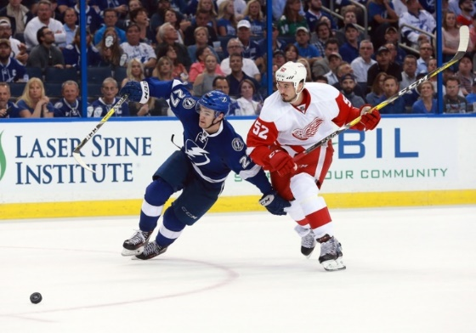
Hockey is a beautiful mess of a game. There are an enumberable things that someone could look at and find interesting about any given effort by a team. Every iota of a season can be analyzed and have stories told about it. So why these two? Despite every convention of the sport, and every normal result put up by hundreds of normal teams, only two made it to the finish by such a wide margin. When they did, they both did it by achieving the exact same number of wins. Two teams who achieved something so similar, yet who were so different. They played 23 years apart, with one man as the sole connection between the two. Both of these seasons ended in disaster, and yet they will always be remembered for accomplishing what no other has; 62 wins.

Thank you for reading “62”

Written, researched, and edited by Dawn Violet Todd

Inspired by the work of Jon Bois

All team, player, and game data courtesy of hockey-reference.com
Newspaper headlines from The Columbus Dispatch and Tampa Bay Times
Detroit vs St. Louis images from archive footage, ESPN
Columbus vs Tampa Bay images from broadcast recording, NBC Sports

Special thanks to:

Early readers Carolynn Judge, Sean Oros, and Ryan Margossian

Brandi Henry, who taught me to always share a story worth telling

Dad

